**P.E.S**

MODERN COLLEGE OF ARTS, SCIENCE & COMMERCE

SHIVAJINAGAR PUNE -5

DEPARTMENT OF STATISTICS

Project Name**:-**

**STUDY OF TRADITIONAL & NON-TRADITIONAL FUELS IN INDIA**

Project Guide: **Prof . Dr. Manisha Sane**

**Head of Department of Statistics**

**P.E.S’s Modern College of Arts, Science & Commerce**

******Presented by: ***Sahil M. Sathe***

***Ishwari R. Sarde***

***Bhakti A. Jadhav***

**CERTIFICATE**

This is to certify that Mr./Miss._______________________________

________________ Student, Roll No. ___________ have satisfactorily carried out the MSc (STATISTICS) project work entitled “STUDY OF TRADITIONAL & NON-TRADITIONAL FUELS”. This work is being submitted in the partial fulfilment of the prescribed syllabus of Modern College of Arts, Science & Commerce, Shivajinagar pune-5 for academic year

2023-24.

Project Guide Head of Department

(Dr . Manisha Sane Mam) (Dr . Manisha Sane Mam)

Internal Examiner External Examiner

INDEX

1.INTRODUCTION

2.MOTIVATION

3.ABSTRACT

4.OBJECTIVES

5.DATA SOURCE & KEYWORDS

6.EXPLORATORY DATA ANALYSIS

7.MODEL FITTING & FORECASTING

8.CORRESPONDENCE ANALYSIS

9.CONCLUSION

10.LIMITATIONS

INTRODUCTION

* Over a century Automobile Industry is gearing up for transformations. The fossil fuel price spike and the impact of its emission on environment have called for a change in individual transportation habits. The sector, propelled by Internal Combustion Engines, is gravitating gradually towards Electric Vehicles. But still we see use of most of the fuels like CNG, LPG, Petrol ,Diesel etc. We need to study that which vehicles cannot easily replaced by EV, what is their count.
* Though electric vehicle (EV) with its zero-emission guarantee is the future of transportation. For a country with a population of 1.4 billion ease of transport is a necessity. Indian transport contributes to around 10% of India carbon emission. India is ready to branch out in a new sustainable way of transportation through the means of an electric vehicle. But still some fuels are not easily replaceable by EV.
* EV Market is currently noticing a Boom in vehicle Market which raises a question about the approval of EV technology and design by the buyers. Simultaneously, all other fuels are still steady in their count.

MOTIVATION

We observed mostly used modes of tranports on the roads, most of them were fuel based. The rising price of fuels in global economy and the rising pollution with it had an adverse our minds. We tried to observe some alternatives among different types of Vehicles. Electric vehicles was the only outstanding solution to all the major arising problems. They produce zero tailpipe emissions, reducing air pollution and dependence on fossil fuels. EVs are generally cheaper to operate than traditional internal combustion engine vehicles due to lower fuel and maintenance costs. Electric motors are much quieter than internal combustion engines, which leads to less noise pollution. But in our day to day life we are so used to other fuels that it is not possible to adapt EV easily. we need to study how much time will we will take to see EV as good mode of transportation then how will it effect on other fuels will their count increase or decrease. Highly used fuels like CNG, LPG, Petrol, Diesel, etc may be not get highly affected by it so easily. The large amount of data when studied properly and Analysed carefully can be used in many future predictions and may help to avoid loss over period of time. We selected this project to get glimpse of many statistical techniques. We can study future values of all fuels and take voluntary actions to increase number of vehicles running on Non-Traditional fuels count.

ABSTRACT

From the past behaviour of traditional fuels in India we conclude that it is not possible to replace them very soon because of people are not sure and aware about the electric vehicle and their benefits related to their cost, reduction in pollution etc.

As we know EV belong to zero carbon emission group so we have Consider top 10 states having most no. of RTO station for our correspondence analysis and we have Conclude in which state we have to increase the awareness of EV.

OBJECTIVES

1) Check which Vehicle Category is mostly used and which Fuel is mostly used in it.

2) To observe growth of Traditional fuels & Non-Traditional fuels in India.

3) To do comparable study of EVS and other fuels like CNG, Petrol, Diesel, LPG for India.

4) To analyse in which States of India we need to spread awareness of Electric Vehicles.

5) To study the increase in count of Traditional & Non-Traditional fuels in next 5 years in India.

Data Source (Link) :   
  
<https://vahan.parivahan.gov.in/vahan4dashboard/vahan/dashboardview.xhtml;jsessionid=4C3A86ADE94A8F88702116553FB2A13F>

KEYWORDS:

* ***Exploratory Data Analysis***
* ***Forecasting***
* ***Time Series Analysis***
* ***Correspondence Analysis***

**EXPLORATORY DATA ANALYSIS:**

We have firstly Perform graphical analysis of fuels Petrol, Diesel, CNG, Electric Vehicles on vehicle categories like Heavy vehicle(Bus, Truck), medium vehicle(Mini Bus,Tempo), light vehicle(Car) ,3 wheelers & 2 wheelers.

1)DIESEL

|  |  |
| --- | --- |
| **VEHICLE CATEGORY** | **DIESEL COUNT** |
| **HEAVY VEHICLE** | **4560791** |
| **MEDIUM VEHICLE** | **930292** |
| **LIGHT VEHICLE** | **27000595** |
| **3WHEELER** | **3920193** |
| **2WHEELER** | **78732** |

**Interpretation : -** We can clearly see that Diesel is highly used in light vehicle.

2)petrol

|  |  |
| --- | --- |
| **VEHICLE CATEGORY** | **PETROL COUNT** |
| **HEAVY VEHICLE** | **5298** |
| **MEDIUM VEHICLE** | **2192** |
| **LIGHT VEHICLE** | **18173864** |
| **3 WHEELER** | **703054** |
| **2 WHEELER** | **179630386** |

**Interpretation:-**From above graph we come to know that Petrol is highly used in 2wheeler

3)ELECTRIC VEHICLE

|  |  |
| --- | --- |
| **VEHICLE CATEGORY** | **EV COUNT** |
| **HEAVY VEHICLE** | **379** |
| **MEDIUM VEHICLE** | **90** |
| **LIGHT VEHICLE** | **16886** |
| **3 WHEELER** | **246347** |
| **2 WHEELER** | **65726** |

Interpretation :- we can see that in 3wheelers electric vehicles are mostly used.

4)CNG

|  |  |
| --- | --- |
| **VEHICLE CATEGORY** | **CNG COUNT** |
| **HEAVY VEHICLE** | **48784** |
| **MEDIUM VEHICLE** | **14683** |
| **LIGHT VEHICLE** | **152837** |
| **3 WHEELER** | **176897** |
| **2 WHEELER** | **355** |

Interpretation :- From above graph we can observe that in 3wheelers CNG is mostly used.

|  |  |  |  |
| --- | --- | --- | --- |
| **VEHICLE CATEGORY** | **TOTAL COUNT** | **FUEL** | **EV** |
| HEAVY VEHICLE | 4615307 | DIESEL | 379 |
| MEDIUM VEHICLE | 947264 | DIESEL | 90 |
| LIGHT VEHICLE | 45367587 | DIESEL | 16886 |
| 3 WHEELER | 5100807 | DIESEL | 246347 |
| 2 WHEELER | 179776242 | PETROL | 65726 |

From above table we can see that highly used vehicle category is 2wheeler in which petrol is highly used. while Diesel is mostly used in other vehicle categories.

Till now mostly EV is used in 3 Wheelers than other any vehicle category. This can be because of government schemes for Auto rickshaw.

**TIME SERIES ANALYSIS**

We have performed Time series analysis on ELECTRIC VEHICLE, CNG, PETROL, DIESEL and LPG.

We have fitted models for each fuels & predicted count for next 5 – 10 yrs.

**1)PETROL**

|  |
| --- |
| > plot.ts(petrol)    > kpss.test(petrol)  KPSS Test for Level Stationarity  data: petrol  KPSS Level = 4.6166, Truncation lag parameter = 4, p-value = 0.01  > adf.test(petrol)  Augmented Dickey-Fuller Test  data: petrol  Dickey-Fuller = -2.1839, Lag order = 6, p-value = 0.4987  alternative hypothesis: stationary    > train=window(petrol,start=(2001),end=c(2015,12))  > train  > test=window(petrol,start=(2016),end=c(2019,12))  > test  > dec=decompose(petrol)  > dec  > plot(dec)    > acf(petrol,type="correlation")  > acf(petrol,type="partial")      model_pt=auto.arima(train,ic="aic",trace = TRUE)  Fitting models using approximations to speed things up...  Now re-fitting the best model(s) without approximations...  ARIMA(4,1,0)(0,1,2)[12] : 4144.001  Best model: ARIMA(4,1,0)(0,1,2)[12]  > model_pt  Series: train  ARIMA(4,1,0)(0,1,2)[12]  Coefficients:  ar1 ar2 ar3 ar4 sma1 sma2  -0.5454 -0.5437 -0.3993 -0.3128 -0.4208 -0.2089  s.e. 0.0758 0.0852 0.0872 0.0776 0.0922 0.0927  sigma^2 = 3.221e+09: log likelihood = -2065  AIC=4144 AICc=4144.71 BIC=4165.83  > forcast=forecast(model_pt,h=132)  > forcast  > res=forcast$residuals  > res  > plot.ts(res)    > Box.test(res)  Box-Pierce test  data: res  X-squared = 0.017144, df = 1, p-value = 0.8958  > acf(res,type="correlation")  > acf(res,type="partial")  > plot(forcast)    > kpss.test(res)  KPSS Test for Level Stationarity  data: res  KPSS Level = 0.074624, Truncation lag parameter = 4, p-value = 0.1  > adf.test(res)  Augmented Dickey-Fuller Test  data: res  Dickey-Fuller = -4.3074, Lag order = 5, p-value = 0.01  alternative hypothesis: stationary  > mres=auto.arima(res,max.p=5,max.q=5)  > mres  Series: res  ARIMA(0,0,0) with zero mean  sigma^2 = 2.881e+09: log likelihood = -2215.75  AIC=4433.49 AICc=4433.52 BIC=4436.69 |
|  |
| |  | | --- | | > | |

forc_test=forecast(model_pt,h=length(test))

forc_test

train_accuray=accuracy(model_pt$fitted,x=train)

train_accuray

ME RMSE MAE MPE MAPE ACF1 Theil's U

Test set 2161.816 53678.24 36924.85 0.1213557 4.906469 -0.009759455 0.5367327

test_accuray=accuracy(forc_test$mean,x=test)

test_accuray

ME RMSE MAE MPE MAPE ACF1 Theil's U

Test set 39511.65 141744.7 108168.3 1.716811 6.408898 0.2751183 0.6352163

Hence,from above graph we can interpret that we get good predictions of Petrol.

**2)DIESEL**

plot.ts(diesel)

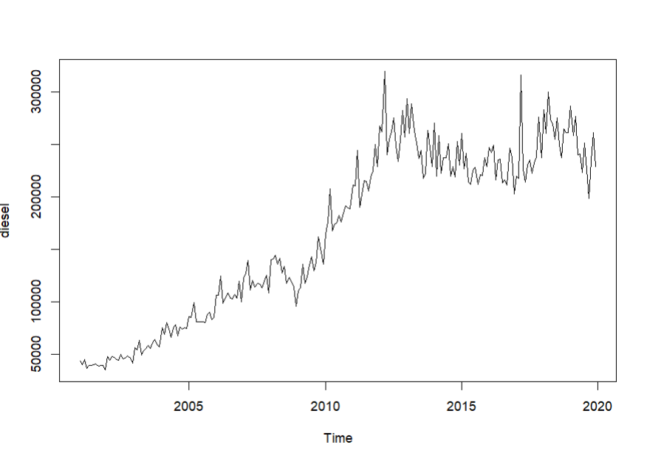

kpss.test(diesel)

KPSS Test for Level Stationarity

data: diesel

KPSS Level = 4.2854, Truncation lag parameter = 4, p-value = 0.01

Conclusion : Since p value <0.05 . Hence The Diesel Time Series is not Trend Stationary

dec=decompose(ev)

dec

plot(dec)

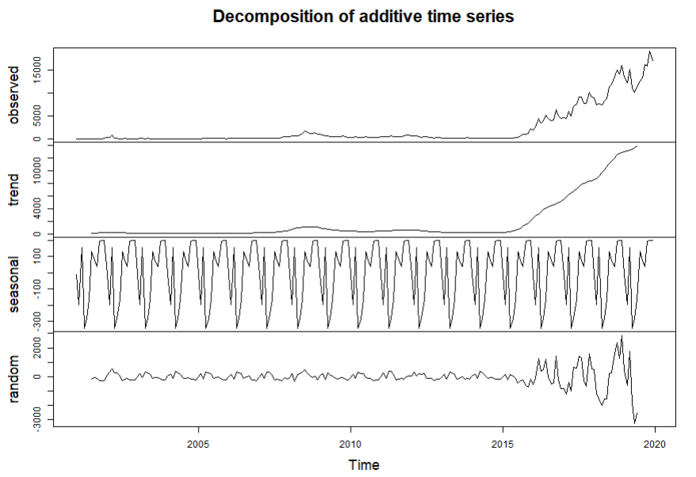

dec1=decompose(ev,type = "multiplicative")

dec1

plot(dec1)

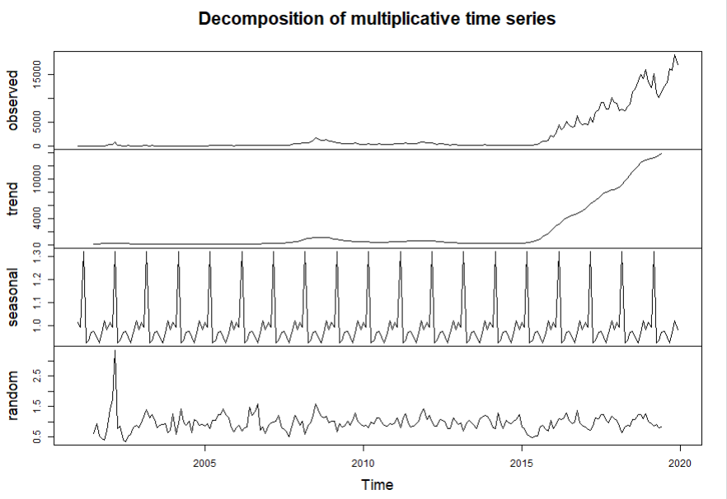

adf.test(ev)

Augmented Dickey-Fuller Test

data: ev

Dickey-Fuller = 0.98551, Lag order = 6, p-value = 0.99

alternative hypothesis: stationary

Conclusion: Hence the time series has unit root .Hence not Stationary

acf(ev,type="correlation")

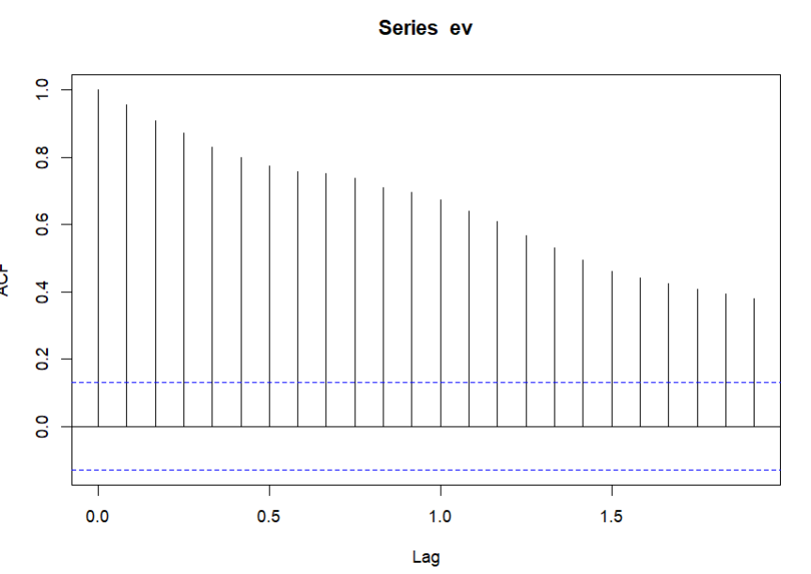

acf(ev,type="partial")

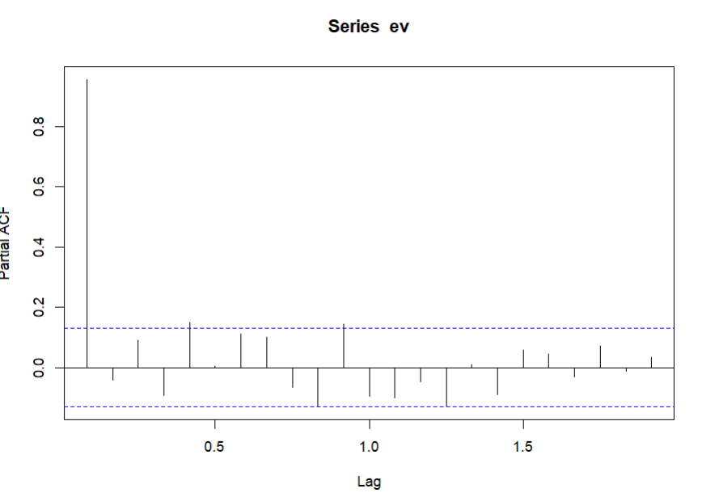

train=window(diesel,start=c(2001),end=c(2015,12))

train

plot.ts(train)

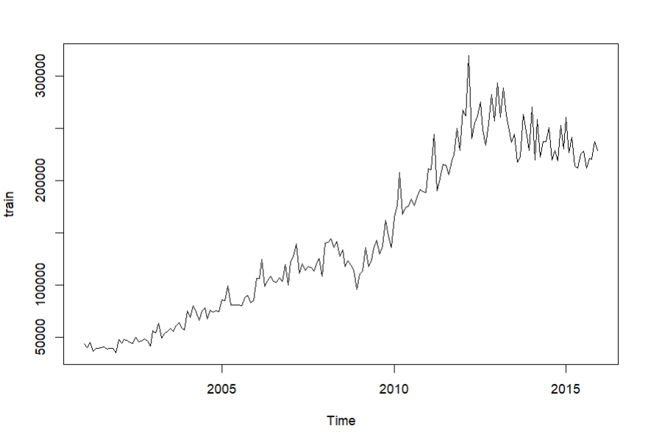

m1=auto.arima(train,seasonal = TRUE)

> m1

Series: train

ARIMA(0,1,1)(0,1,1)[12]

Coefficients:

ma1 sma1

-0.4427 -0.5594

s.e. 0.0635 0.0820

sigma^2 = 1.21e+08: log likelihood = -1792.36

AIC=3590.72 AICc=3590.86 BIC=3600.07

fm1=forecast(m1,h=132)

fm1

res1=fm1$residuals

plot.ts(res1)

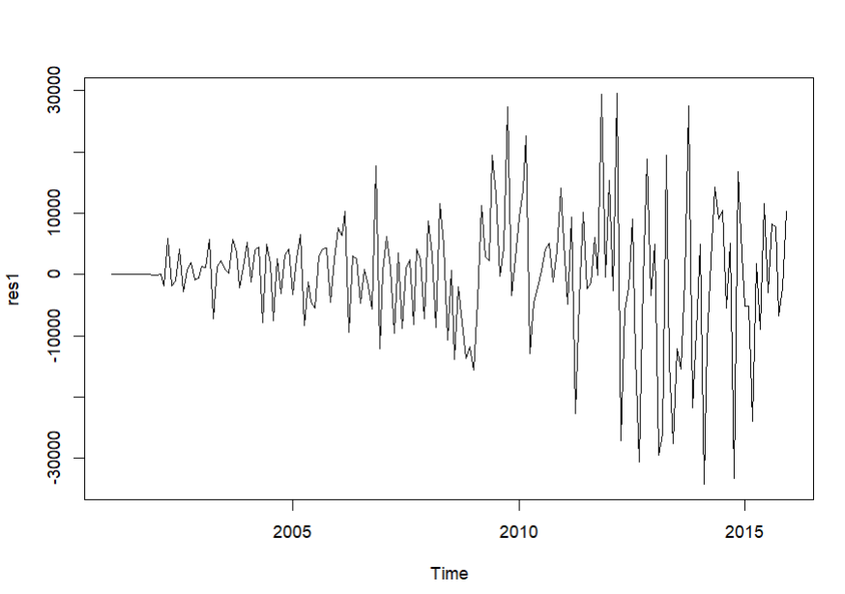

Box.test(res1)

Box-Pierce test

data: res1

X-squared = 0.11406, df = 1, p-value = 0.7356

Conclusion: Hence the residuals follow White Noise Seq.

acf(res1,type="correlation")

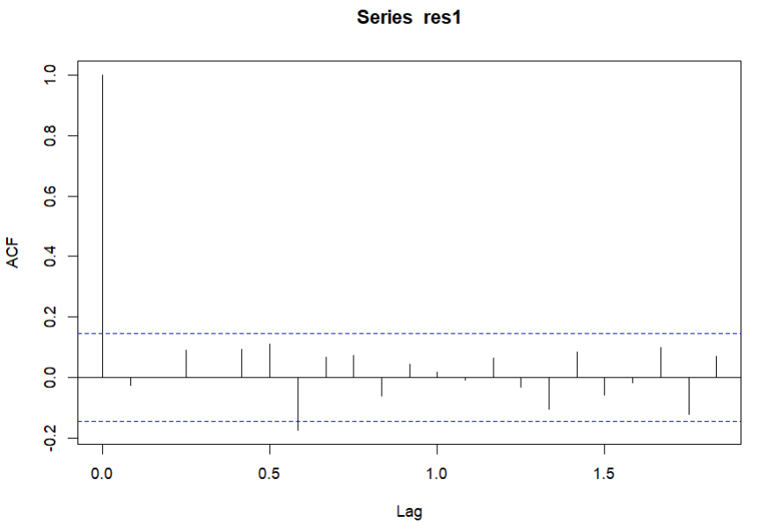

acf(res1,type="partial")

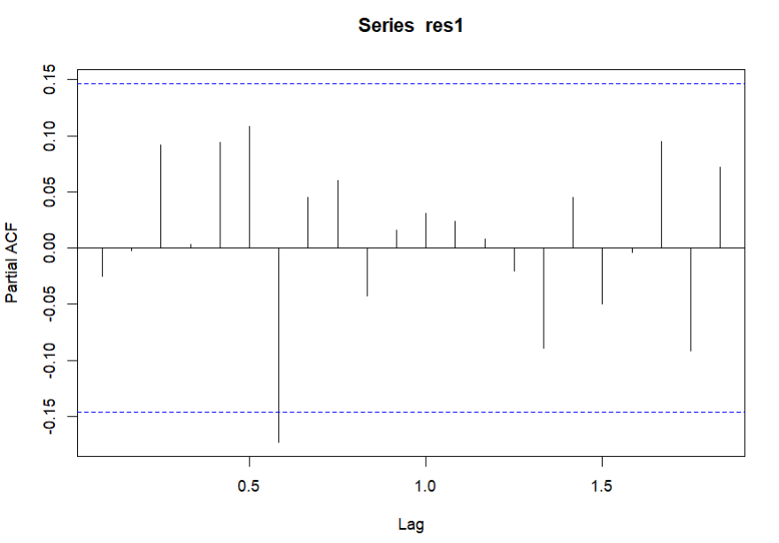

kpss.test(res1)

KPSS Test for Level Stationarity

data: res1

KPSS Level = 0.2041, Truncation lag parameter = 4, p-value = 0.1

Hence the residuals seq is trend Stationary

adf.test(res1)

Augmented Dickey-Fuller Test

data: res1

Dickey-Fuller = -4.2211, Lag order = 5, p-value = 0.01

alternative hypothesis: stationary

Hence the residuals seq is unit root Stationary mres1=auto.arima(res1,max.p=5,max.q=5)

mres1

|  |
| --- |
| Series: res1  ARIMA(0,0,0) with zero mean  sigma^2 = 110911915: log likelihood = -1922.59  AIC=3847.18 AICc=3847.2 BIC=3850.38 |
|  |
|  |

|  |
| --- |
|  |

|  |
| --- |
| test=window(diesel,start=(2016),end=c(2019,12))  > test  > forc_test=forecast(m1,h=length(test))  > forc_test  train_accuray=accuracy(m1$fitted,x=train)  > train_accuray  ME RMSE MAE MPE MAPE ACF1 Theil's U  Test set -149.5837 10531.47 7217.679 -0.04463883 4.768957 -0.02517276 0.5584861  > test_accuray=accuracy(forc_test$mean,x=test)  > test_accuray  ME RMSE MAE MPE MAPE ACF1 Theil's U  Test set 15423.28 26268.19 21431 5.620251 8.411365 0.4759261 0.873657 |
|  |
| |  | | --- | |  | |

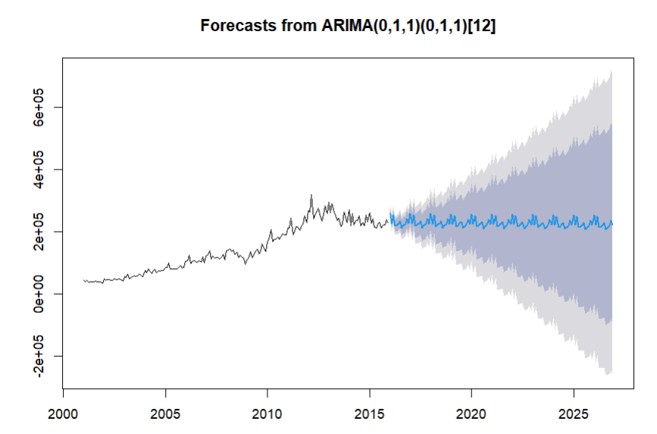

Hence,from above graph we can say that for next 5 yrs count of Diesel will be stable.

3)CNG

|  |
| --- |
| > plot.ts(d) |
|  |
| |  | | --- | |  | |

|  |
| --- |
| kpss.test(d)  KPSS Test for Level Stationarity  data: d  KPSS Level = 1.5232, Truncation lag parameter = 5, p-value = 0.01  > ### Estimating and eliminating trend  > trend=ma(d,order=12)  > trend  > detrend=d-trend  > detrend  > plot.ts(detrend) |
|  |
| |  | | --- | |  | |

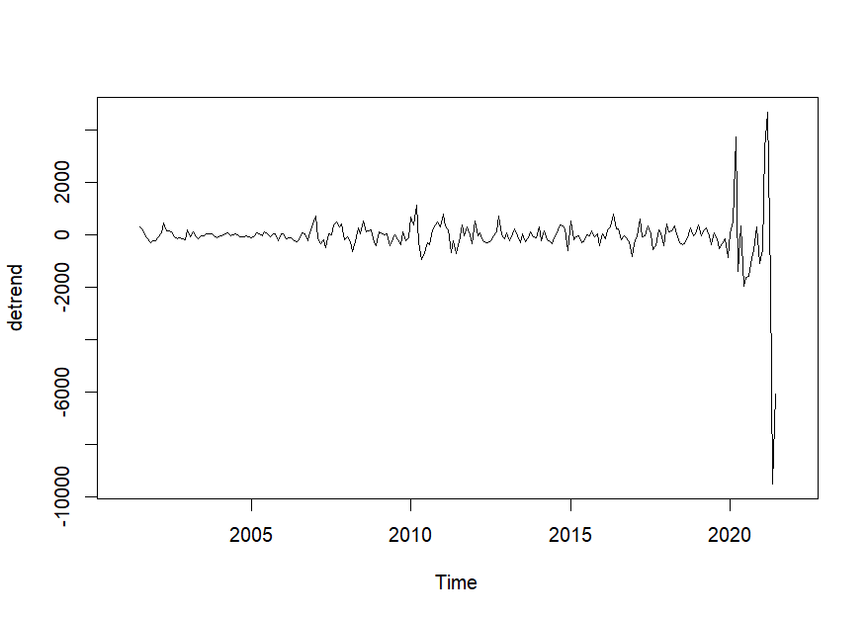

### Deseasonalizing data

> season=decompose(d)

> s=season$figure

> s

[1] 252.44774 227.95399 588.69983 -108.67101 -495.08976 -461.23351 1.59566 -52.90434

[9] 20.36024 146.97066 69.60399 -189.73351

> deseason=detrend-s

> deseason

> plot.ts(deseason)

> kpss.test(deseason)

KPSS Test for Level Stationarity

data: deseason

KPSS Level = 0.34303, Truncation lag parameter = 5, p-value = 0.1

### Hence Now the Stationarity is achieved.

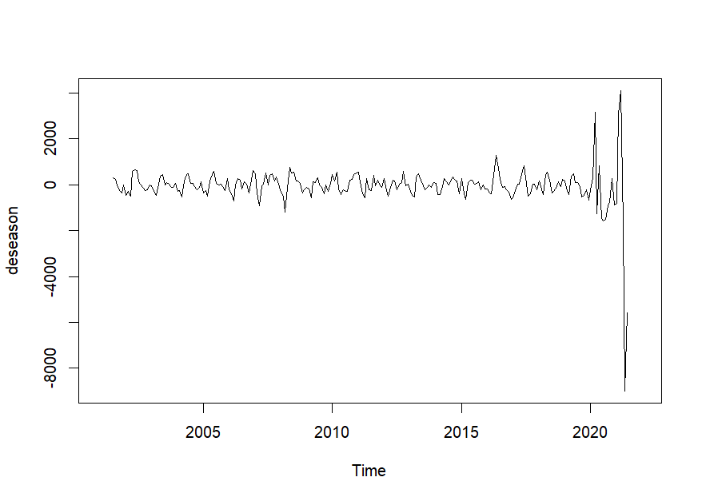

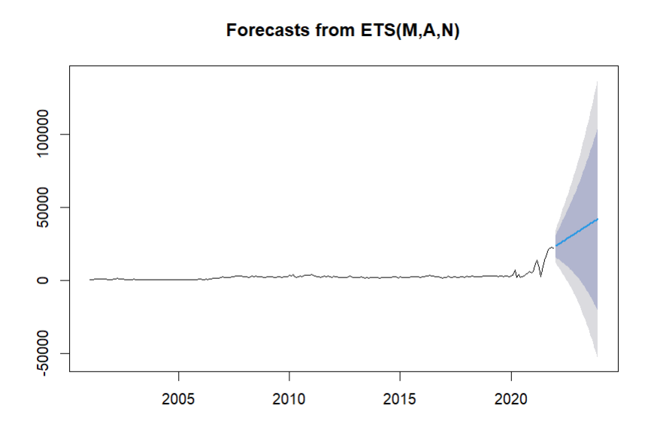

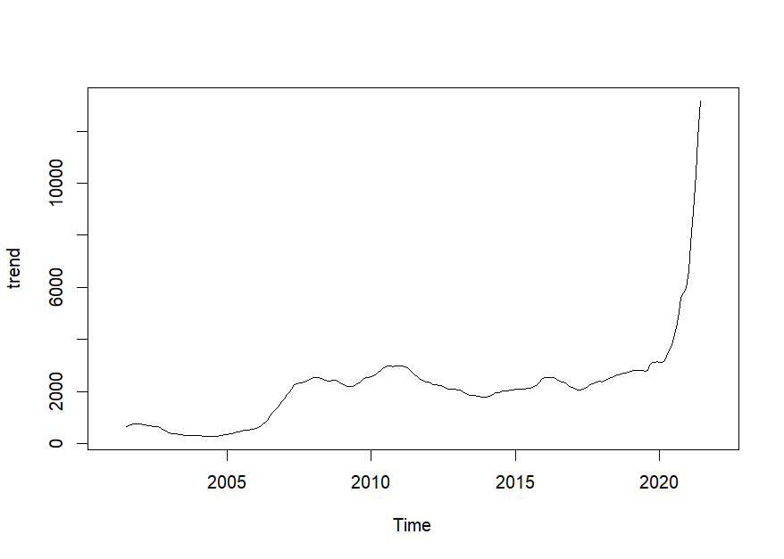

> m1=auto.arima(deseason,max.p=7,max.q=7)

> m1

Series: deseason

ARIMA(3,0,1) with zero mean

Coefficients:

ar1 ar2 ar3 ma1

0.0716 -0.2610 -0.6570 0.4839

s.e. 0.1381 0.1017 0.0973 0.1502

sigma^2 = 440572:

log likelihood = -1899.42

AIC=3808.84 AICc=3809.09 BIC=382

|  |
| --- |
| forc=forecast(d,h=12)  > forc=forecast(d,h=24)  > forc  > forc_arima=forecast(m1,h=24)  > forc_arima  > df_forc=as.data.frame(forc_arima)  > df_forc  > df_forc["Point Forecast"]  > plot.ts(forc_arima)  > resid_arima=residuals(m1)  > resid_arima  > plot.ts(trend)  > plot.ts(resid_arima)  > Box.test(resid_arima)  Box-Pierce test  data: resid_arima  X-squared = 1.63e-05, df = 1, p-value = 0.9968  >  > forc=forecast(d,h=24)  > forc  > plot(forc)  > mt_trend=as.matrix(trend,start=c(2001,1))  > ###b Accuracy  > accuracy(forc)  ME RMSE MAE MPE MAPE MASE ACF1  Training set 76.35875 1107.064 471.5562 -5.153044 19.70939 0.4821042 0.3290804  > accuracy(forc_arima)  ME RMSE MAE MPE MAPE MASE ACF1  Training set -43.33682 658.2015 372.1162 82.34837 450.4103 0.9741335 0.0002606121 |
|  |
| |  | | --- | | > |   ACTUAL PREDICTIONS-   |  | | --- | | forc=forecast(d,h=60)  > forc  > plot(forc) | |  | | |  | | --- | |  | | |

**4)ELECTRIC VEHICLE**

|  |
| --- |
| KPSS Test for Level Stationarity  data: d  KPSS Level = 2.3359, Truncation lag parameter = 5, p-value = 0.01  > train=window(d,start=(2010),end=c(2021,12))  > train  > m2=auto.arima(train,ic="aic",trace =TRUE)  Best model: ARIMA(3,1,1)(1,0,0)[12] with drift  > m2  Series: train  ARIMA(3,1,1)(1,0,0)[12] with drift  Coefficients:  ar1 ar2 ar3 ma1 sar1 drift  0.9926 -0.4887 0.4137 -0.7677 0.6789 1313.631  s.e. 0.1187 0.1083 0.0803 0.1066 0.0901 1536.980  sigma^2 = 5352501: log likelihood = -1312.04  AIC=2638.09 AICc=2638.92 BIC=2658.83  > forc_m2=forecast(m2,h=120)  > forc_m2 |
|  |
| |  | | --- | | > | |

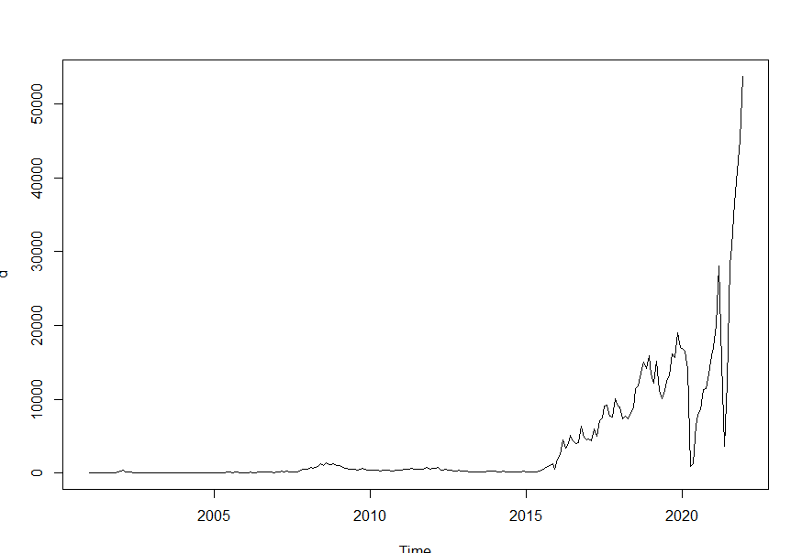

Hence, from all graphs given below we can say that count of EV is increasing highly. Future of India is being seen good with EV. In future, their will be boom in EV market.

**Comparative study of ev & other fuels**

1)EV & PETROL

We can interpret that it will not be easy for EV to overtake petrol. But count of EV is rising.

2)EV & DIESEL

We can interpret that it will not be easy for EV to overtake DIESEL but EV is increasing.

3) EV & LPG

We can interpret that it will not be easy for EV to overtake DIESEL but EV will increase increasing.

4)EV & CNG

We can interpret EV is increasing and CNG will remain constant.

|  |  |  |
| --- | --- | --- |
| **Parameters** | **CNG** | **EV** |
| **Emission** | Lower emission | zero emission |
| **Initial Investment** | More costly than fossil fuel | More costly than CNG |
| **Maintenance Costs** | Higher than petrol cars | Less than CNG |

Hence, from above chart we can say that EV is more beneficial than CNG. We should increase awareness of EV.

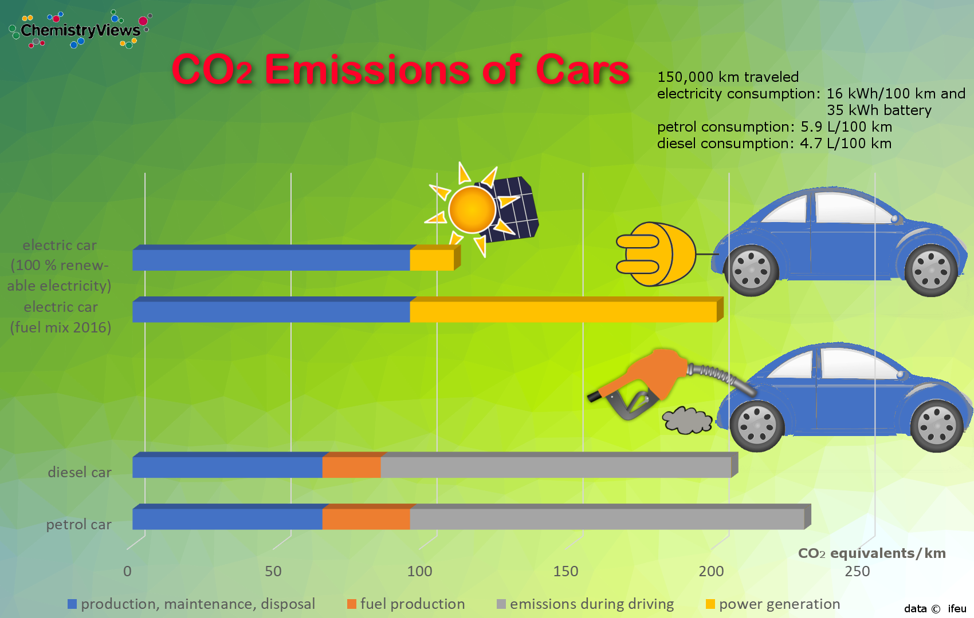

**CORRESPONDENCE ANALYSIS**

Correspondence analysis is also called as RECIPROCAL AVERAGING, is a useful data science visualization technique for finding out and displaying the relationship between categories. It uses that plots data, visually showing outcome of two or more data points.

FUELWISE CLUSTERING OF STATES:-

Here, we have taken data of ten states of India namely Maharastra, Tamilnadu, Kerala, Karnakata, Himachal Pradesh, Haryana, Uttar Pradesh, Andra Pradesh, Punjab & Rajasthan. Based on high number of RTO’s present in states. Here, we have Analyse which states needed to be get aware about EV.

**Code:**

library("FactoMineR")

library("factoextra")

library("gplots")

library("ca")

data=read.csv("C:\\Users\\Ishwari\\Desktop\\EV CLUSTERING DATA.csv",row.names = 1)

data

names(data)

attach(data)

head(data)

df=as.data.frame(data)

df

res.ca=ca(df,graph=FALSE)

res.ca

chisq.test(df)

EV=get_eigenvalue((res.ca))

EV

fviz_screeplot(res.ca,addlabels=TRUE,ylim=c(0,50))

row=get_ca_row(res.ca)

row

head(row$coord)

head(row$cos2)

head(row$contrib)

fviz_ca_row(res.ca,repel = TRUE)

fviz_ca_biplot(res.ca,repe=TRUE)

fviz_ca_biplot(res.ca,map="rowprincipal",arrow=c(TRUE,TRUE),repel=TRUE)

EV CNG PETROL DIESEL

MAHARATRA 3260 1371 150789 24118

TAMILNADU 1733 353 129084 14261

RAJASTHAN 1905 262 87508 17129

HARYANA 715 1066 44678 10861

HIMACHAL 24 2 8769 1619

PUNJAB 387 127 47074 8942

KERALA 1071 261 61675 7567

AP 666 136 68593 11874

UP 6106 1483 205788 22834

KARNATAKA 2591 518 103020 16511

Principal inertias (eigenvalues):

1 2 3

Value 0.00768 0.003173 0.001034

Percentage 64.61% 26.69% 8.7%

chisq.test(df)

Pearson's Chi-squared test

data: df

X-squared = 126

81, df = 27, p-value < 2.2e-16







Interpretation :- From above plots we can see that petrol & Diesel are highly used in all states but CNG & EV need to be get more aware among population of respective states.

CORRESPONDENCE ANALYSIS OF ONLY EV:

Here,we have taken same states but data of EV count from 2015 till today .to know which states is needed to get aware of EV ,to know about zero carbon emission misson of 2070.

**code**

> library("FactoMineR")

> library("factoextra")

> library("gplots")

> library("ca")

> library("ade4")

> library("amap")

> library("MASS")

> data=read.csv("C:\\Users\\Ishwari\\Desktop\\ONLY EV CLUSTERING.csv",row.names = 1)

> data

MAHARATRA TAMILNADU RAJASTHAN HARYANA HIMACHAL PUNJAB KERALA AP UP KARNATAKA

2015 1011 86 676 55 4 18 27 8 1012 682

2016 943 86 3996 1380 4 38 19 20 15310 599

2017 943 118 3945 2488 15 137 77 0 40649 727

2018 4640 1332 4578 4623 62 363 272 1167 53211 2295

2019 7318 3444 6633 5108 5 961 478 2125 55796 6148

2020 7135 5697 5604 2982 181 832 1360 1624 31268 9709

2021 29914 30030 23464 8660 327 4643 8742 9578 66722 33312

2022 136055 66953 78240 25865 1008 14053 39622 29137 162860 95899

2023 160825 77633 76715 25333 941 20382 64034 27629 226511 127882

> names(data)

[1] "MAHARATRA" "TAMILNADU" "RAJASTHAN" "HARYANA" "HIMACHAL" "PUNJAB" "KERALA"

[8] "AP" "UP" "KARNATAKA"

> attach(data)

> head(data)

MAHARATRA TAMILNADU RAJASTHAN HARYANA HIMACHAL PUNJAB KERALA AP UP KARNATAKA

2015 1011 86 676 55 4 18 27 8 1012 682

2016 943 86 3996 1380 4 38 19 20 15310 599

2017 943 118 3945 2488 15 137 77 0 40649 727

2018 4640 1332 4578 4623 62 363 272 1167 53211 2295

2019 7318 3444 6633 5108 5 961 478 2125 55796 6148

2020 7135 5697 5604 2982 181 832 1360 1624 31268 9709

> df=as.data.frame(data)

> df

MAHARATRA TAMILNADU RAJASTHAN HARYANA HIMACHAL PUNJAB KERALA AP UP KARNATAKA

2015 1011 86 676 55 4 18 27 8 1012 682

2016 943 86 3996 1380 4 38 19 20 15310 599

2017 943 118 3945 2488 15 137 77 0 40649 727

2018 4640 1332 4578 4623 62 363 272 1167 53211 2295

2019 7318 3444 6633 5108 5 961 478 2125 55796 6148

2020 7135 5697 5604 2982 181 832 1360 1624 31268 9709

2021 29914 30030 23464 8660 327 4643 8742 9578 66722 33312

2022 136055 66953 78240 25865 1008 14053 39622 29137 162860 95899

2023 160825 77633 76715 25333 941 20382 64034 27629 226511 127882

> res.ca=ca(df,graph=FALSE)

> res.ca

Principal inertias (eigenvalues):

1 2 3 4 5 6 7 8

Value 0.107347 0.006564 0.003745 0.001118 0.00065 9.6e-05 8.1e-05 1e-05

Percentage 89.75% 5.49% 3.13% 0.93% 0.54% 0.08% 0.07% 0.01%

Rows:

2015 2016 2017 2018 2019 2020 2021 2022

Mass 0.001812 0.011339 0.024860 0.036731 0.044565 0.033616 0.109060 0.328959

ChiDist 0.559805 0.913658 1.097726 0.901634 0.685093 0.353334 0.201439 0.178955

Inertia 0.000568 0.009466 0.029957 0.029860 0.020917 0.004197 0.004425 0.010535

Dim. 1 0.219822 -2.598848 -3.335356 -2.738822 -2.081149 -0.959325 0.102142 0.496669

Dim. 2 0.804094 -0.507505 0.896701 0.533017 -0.158591 -1.068492 -2.252587 -0.355398

2023

Mass 0.409057

ChiDist 0.153889

Inertia 0.009687

Dim. 1 0.398624

Dim. 2 0.899609

Columns:

MAHARATRA TAMILNADU RAJASTHAN HARYANA HIMACHAL PUNJAB KERALA AP

Mass 0.176600 0.093863 0.103216 0.038731 0.001290 0.020976 0.058041 0.036095

ChiDist 0.287234 0.321372 0.174636 0.222375 0.361066 0.289003 0.429107 0.288517

Inertia 0.014570 0.009694 0.003148 0.001915 0.000168 0.001752 0.010687 0.003005

Dim. 1 0.827672 0.829610 0.250392 -0.566436 0.594075 0.827715 1.138329 0.737972

Dim. 2 0.842618 -1.823853 -0.859424 -0.946726 -1.913255 0.641400 2.425780 -1.476730

UP KARNATAKA

Mass 0.330806 0.140382

ChiDist 0.442954 0.263744

Inertia 0.064907 0.009765

Dim. 1 -1.350100 0.768212

Dim. 2 0.211434 -0.147185

> chisq.test(df)

Pearson's Chi-squared test

data: df

X-squared = 236232, df = 72, p-value < 2.2e-16

> EV=get_eigenvalue((res.ca))

> EV

eigenvalue variance.percent cumulative.variance.percent

Dim.1 1.073467e-01 89.74611108 89.74611

Dim.2 6.564114e-03 5.48786018 95.23397

Dim.3 3.745437e-03 3.13133384 98.36531

Dim.4 1.118378e-03 0.93500863 99.30031

Dim.5 6.500482e-04 0.54346614 99.84378

Dim.6 9.550567e-05 0.07984653 99.92363

Dim.7 8.131058e-05 0.06797888 99.99161

Dim.8 1.004107e-05 0.00839473 100.00000

> fviz_screeplot(res.ca,addlabels=TRUE,ylim=c(0,50))

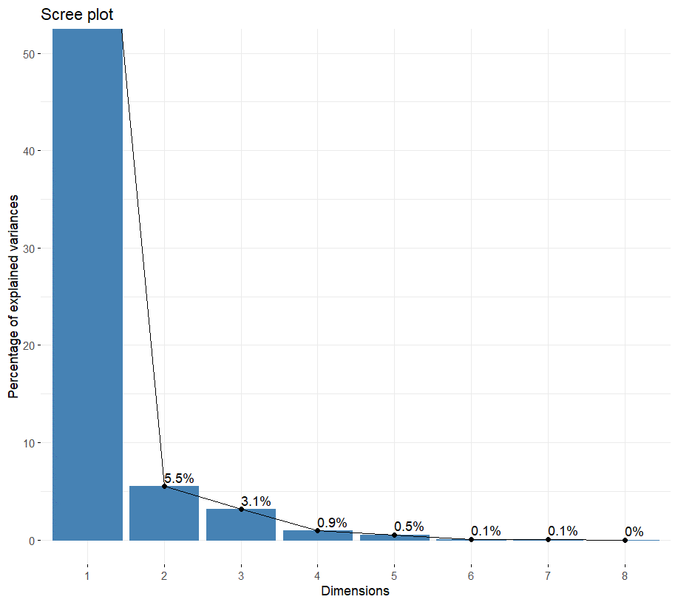

|  |
| --- |
| row=get_ca_row(res.ca)  > row  Correspondence Analysis - Results for rows  ===================================================  Name Description  1 "$coord" "Coordinates for the rows"  2 "$cos2" "Cos2 for the rows"  3 "$contrib" "contributions of the rows"  4 "$inertia" "Inertia of the rows"  > head(row$coord)  Dim.1 Dim.2 Dim.3 Dim.4 Dim.5 Dim.6  2015 0.07202207 0.06514703 0.340945961 -0.19568931 -0.36203141 0.12938155  2016 -0.85148156 -0.04111765 0.249121130 -0.20542462 0.04439940 -0.02909082  2017 -1.09278956 0.07265004 -0.002637120 -0.05590738 0.03228217 0.01961823  2018 -0.89734222 0.04318461 0.005927420 0.07285193 0.01017979 -0.01341357  2019 -0.68186379 -0.01284894 -0.003288612 0.05373265 -0.01639547 0.01514242  2020 -0.31431142 -0.08656837 -0.089899793 -0.02334018 -0.09566778 -0.02707222  Dim.7 Dim.8  2015 -0.024379949 0.031789942  2016 0.030987576 0.004670100  2017 -0.029932924 -0.008876569  2018 -0.011326270 0.010052450  2019 0.028983340 -0.003685415  2020 -0.005240498 -0.004424267  > head(row$cos2)  Dim.1 Dim.2 Dim.3 Dim.4 Dim.5 Dim.6  2015 0.0165523 0.0135430499 3.709354e-01 0.122197255 0.4182343846 0.0534160673  2016 0.8685259 0.0020252974 7.434528e-02 0.050551874 0.0023614916 0.0010137809  2017 0.9910271 0.0043801010 5.771281e-06 0.002593885 0.0008648444 0.0003193979  2018 0.9905032 0.0022940222 4.321864e-05 0.006528627 0.0001274728 0.0002213239  2019 0.9905938 0.0003517507 2.304228e-05 0.006151442 0.0005727272 0.0004885299  2020 0.7913161 0.0600272112 6.473618e-02 0.004363531 0.0733096374 0.0058705296  Dim.7 Dim.8  2015 0.0018966745 3.224829e-03  2016 0.0011502903 2.612670e-05  2017 0.0007435509 6.538870e-05  2018 0.0001578024 1.243036e-04  2019 0.0017897699 2.893831e-05  2020 0.0002199757 1.567878e-04  > head(row$contrib)  Dim.1 Dim.2 Dim.3 Dim.4 Dim.5 Dim.6 Dim.7  2015 0.008756662 0.1171681 5.624252225 6.204998 36.5378575 31.762281 1.324691  2016 7.658563007 0.2920559 18.789022592 42.786013 3.4386985 10.047736 13.391020  2017 27.656132539 1.9989534 0.004615985 6.947950 3.9855391 10.018380 27.394181  2018 27.552273146 1.0435464 0.034455526 17.431044 0.5855475 6.919736 5.795044  2019 19.302013306 0.1120868 0.012868229 11.504930 1.8428839 10.699359 46.041118  2020 3.093725657 3.8378902 7.253792410 1.637457 47.3299441 25.796966 1.135398  Dim.8  2015 18.238779  2016 2.462963  2017 19.508214  2018 36.965278  2019 6.028219  2020 6.553194  > fviz_ca_row(res.ca,repel = TRUE) |
|  |
| |  | | --- | | > | |

> fviz_ca_row(res.ca,repel = TRUE)

> fviz_ca_biplot(res.ca,repe=TRUE)

> fviz_ca_biplot(res.ca,map="rowprincipal",arrow=c(TRUE,TRUE),repel=TRUE)

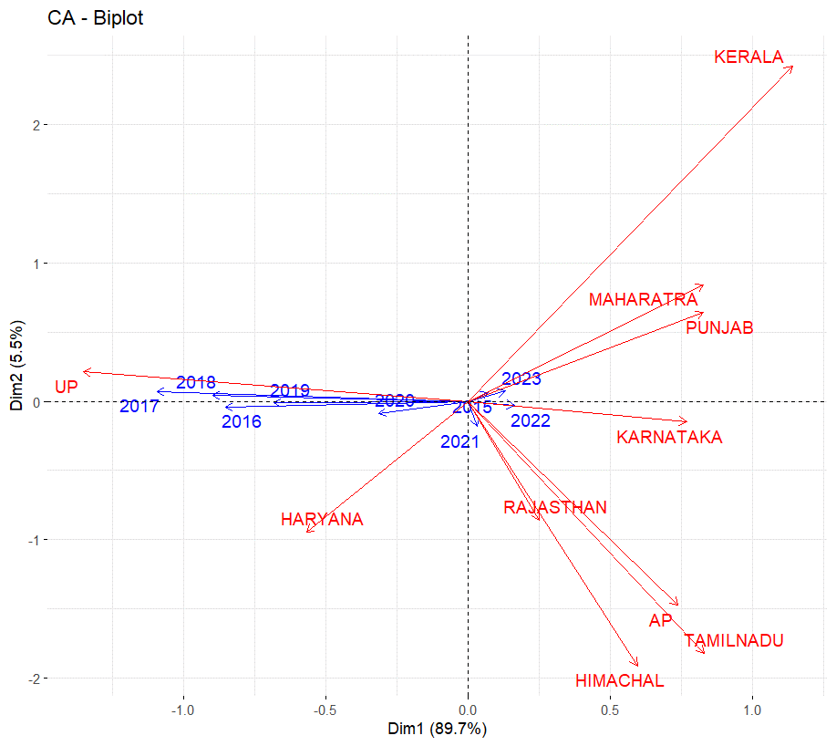

INTERPRETATION:- From above plot we can see that Maharastra, Punjab, Karnataka, Haryana & UP have good number of Electronic Vehicles . But we need to spread awareness about EV in AP, Himachal Pradesh & Tamilnadu.

**CONCLUSION**

This study has discussed the application of time series study of TRADITIONAL & NON-TRADITIONAL FUELS.

According to data study it is observed that –

1)Highly used vehicle category is 2wheeler in which petrol is highly used. while, Diesel is mostly used in other vehicle categories.

2) Electric vehicle is Future of India. Their will be highly increased in Electric Vehicle.

3) As Diesel and Petrol are our traditional fuels it will not be easy for Electric vehicle to increased its count than these fuels.

4)According to clustering, Andhra Pradesh, Himachal Pradesh, Punjab and Haryana are the states in which awareness of Electric Vehicle should be increased.

The common reasons we have seen in all the states for least number of EV are the limited charging infrastructure (most cities/towns still do not have charging stations), recent EV battery-related explosions in various parts of the state, the high upfront cost compared to conventional vehicles, and doubts over the range (distance one can travel with a single charge) .

We can also say that if EV will use electricity from Coal then it will be not useful for zero carbon emission. Instead, if we shift to solar panels, windmills, Hydro-electric power, etc then it will be very helpful for our future.

**LIMITATIONS**

1)Due to Corona pandemic their was high decreased in number of all vehicles which has affected our forecasting.

2)Due to small amount of data of Electric Vehicles, its prediction was worthless.

**~~THANK YOU~~**